**Environment:**

Python 3.7 + PyCharm Community

1. **Install Python 3:**

Remember to check on **‘Add Python to environment variables’**, otherwise you wouldn’t be able to use **python** or **python3** command on command/terminal.

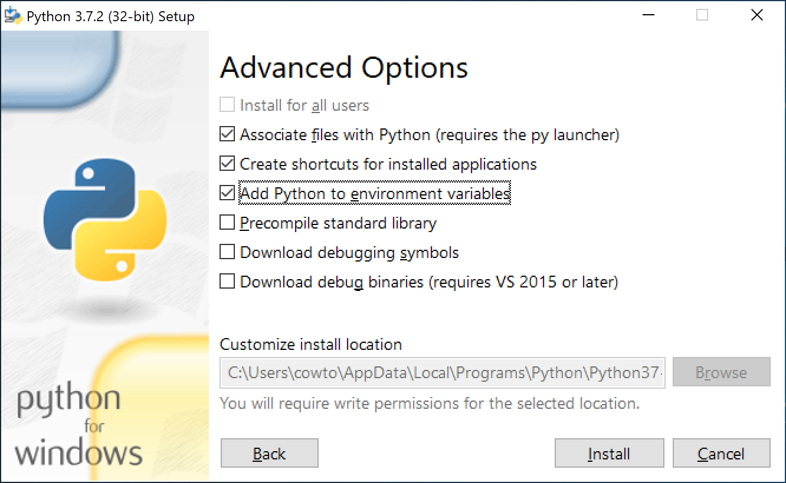

1. **Install PyGame for IDLE:**

**$ python3 -m pip install -U pygame –user**

* If you see 'python3' is not recognized as an internal or external command, that means you don’t have python 2 installed on your computer, which means you don’t need to use python3 to specify python version, just use **python** instead.
* -m means mod, run library module as a script (terminates option list).
* -U means upgrade, upgrade all specified packages to the newest available version. The handling of dependencies depends on the upgrade-strategy used.
* We use the --user flag to tell it to install into the home directory, rather than globally.
* To see if it works, run one of the included examples: $ python3 -m pygame.examples.aliens

1. **Install PyGame for PyCharm:**

Under **File**->**Settings…**

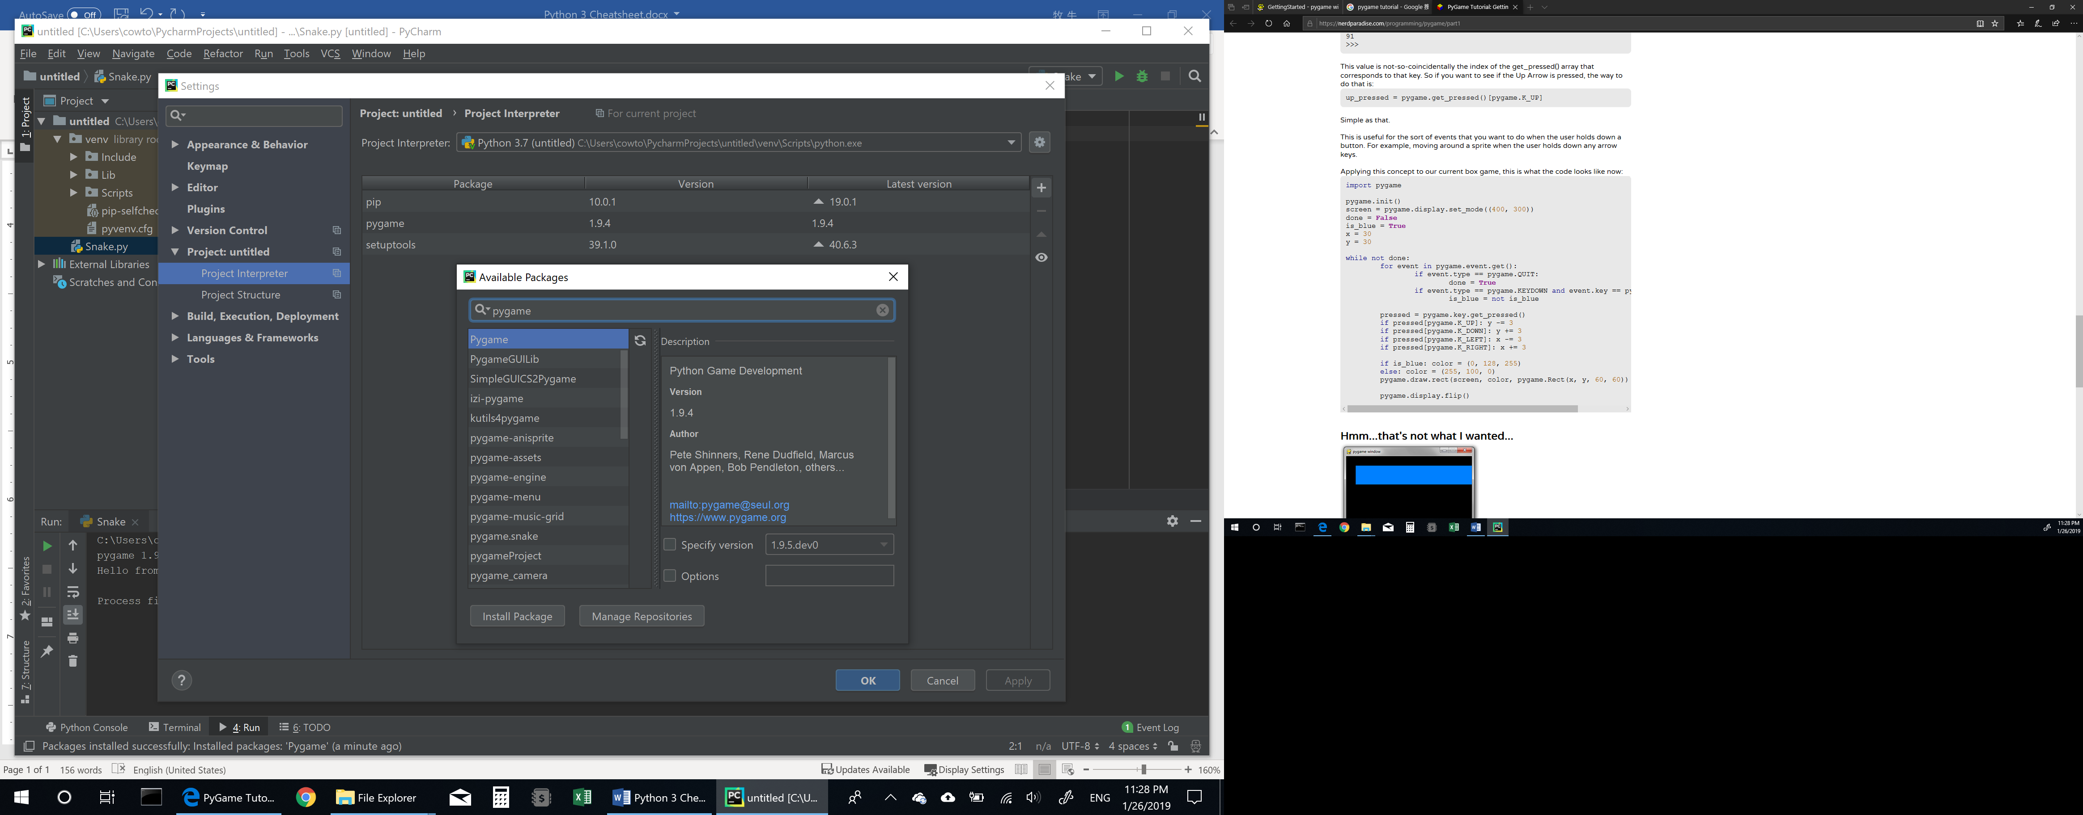



1. Tutorial Link:

https://nerdparadise.com/programming/pygame/part1

1. First thing to use pygame:

import pygame

pygame.init()

1. How to create a screen?

screen = pygame.display.set_mode((500, 500))

pygame.display.set_caption("My First Game") # optional

1. How to keep the screen? A general structure:

carryOn = True  
while carryOn:  
 for event in pygame.event.get():

if event.type == pygame.QUIT:   
 carryOn = False  
 # your code goes here  
 pygame.display.flip()

1. Color:

RGB – Red, Green, Blue (0 – 255, 0 – 255, 0 – 255)

1. Draw Rectangular / Line / Circle / Polygon / Lines / Ellipse:

pygame.draw.line(screen, BLUE, (200, 250), (100, 200), 3)

pygame.draw.rect(screen, BLUE, [200, 250, 100, 200], 2)

pygame.draw.polygon(screen, BLUE, [(10, 10), (40, 40), (40, 10)], 2)

pygame.draw.lines(screen, BLUE, False, [(110, 10), (140, 40), (140, 10)], 2)

pygame.draw.circle(screen, BLUE, (100, 100), 50, 8)

pygame.draw.ellipse(screen, BLUE, [200, 250, 100, 200], 5)

1. Change Background and clear the screen:

screen.fill(WHITE)

1. Take Keyboard input:

keys = pygame.key.get_pressed() # Check keyboard input

if keys[pygame.K_LEFT]:

# code

if keys[pygame.K_RIGHT]:

# code

if keys[pygame.K_UP]:

# code

if keys[pygame.K_DOWN]:

# code

1. Clock:

clock = pygame.time.Clock()

clock.tick(30)

1. Use a list to store a snake:
2. ~~Load Image:~~

~~carImg = pygame.image.load('racecar.png')~~

~~image = pygame.transform.scale(image, (50, 60))~~

~~screen.blit(carImg, (x,y))~~

1. ~~Background music:~~